**24/3/2025**

**Introduction to Control System (got time only read)**

* The terms, control and system are closely interrelated. Control is the process of forcing a system output variable to conform to some desired value, called reference value.
* In order to gain a better understanding of the task of control, a simple example is considered. Driving a car is an excellent example of control system. The driver has to follow the given direction of a road. He/she observes the actual path of the car and then forces the car, operating the steering wheel, to track the desired path as closely as possible. The driver performs the following steps in detail:
* The driver uses his eyes as sensors for obtaining measurements, both of the car’s actual path and the road course.
* Then he/she compares both directions and generates an error signal, which is used to decide in which direction to move the steering wheel.
* The driver actuates the steering wheel according to his decision, making the car, the controlled object, move to the desired direction.

**What is an open-loop control system**

Those systems in which the **output has no effect on the control action** are called open-loop control systems. In other words, in an open-loop control system the output is neither measured nor feedback for comparison with the input.

One practical example is a **simple fan**, where:

**Plant/Process/System** - refers to the system (simple fan) we want to control. It generally refers to a physical process which we can either model or measure**.**

**Reference input/Desired Output** - Switch on the fan (that is, press the switch and 230 V is applied). So, the reference input is the 230 V signal.

**Controller** - The electronic voltage controller (that is, turn the knob to the desired position). The effect is to reduce/change the voltage to the appropriate value. We may have approximately 230 V (= full speed) and 115 V (half-speed), and so on.

Once the speed is set there is nothing else that needs to be done. But suppose you have three fans. Even if you give their knobs旋钮 the same amount of turn, the speeds are likely to be slightly different. This may happen due to inaccuracy in the settings, inconsistency in ball bearings performance, imperfect setting of the fan blades causing different amount of drag on the blades, or maybe due to non-standard performance of the electronic components.

So, essentially an open-loop system is one where there is no way to correct the error between the desired output and the actual output.

**What is a closed-loop control system?**

* **Feedback control systems** are often referred to as **closed-loop control systems**. In practice, the terms feedback control and closed-loop control are used interchangeably.
* Consider the same electronic fan control switch. Assume that you are looking at the fan blades风扇叶片 to make sure that the speed is right. If it isn’t, then you turn the knob continuously till the desired speed is achieved. The block diagram in Figure 3 is not an exact representation of this, but it conveys the idea in a broad sense. The measurement device or transducer is to convert the output signal to an equivalent electrical system (e.g. from kinetic energy to electrical energy). This facilitates the comparison of the output signal to the input.

Control system not in EXAM, but PID yes

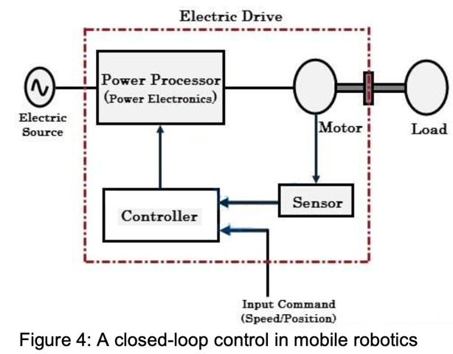

* The measured speed at the motor shaft is fed back and compared with reference speed.
* The difference speed error is applied to the controller to generate a control voltage which controls the power processor and produces the desired terminal voltage.
* This terminal voltage controls the speed of the motor and thus the speed of the motor can maintained for any variations in the load torque负载扭矩.
* If the load torque has been increased, due to this high load the motor speed reduces momentarily暂时 from its desired value.
* Closed-loop systems have different characteristics when compared to open-loop systems. The following summarizes the advantages and disadvantages of closed-loop system:

**Advantages:**

* Highly accurate as any error arising is corrected due to presence of feedback signal.
* They are less sensitive to disturbances骚乱.
* They are less sensitive to system characteristics/parameter variations.

**Disadvantages:**

* They have a tendency to oscillate摆动.
* They are complicated to design.
* Required more maintenance.
* Stability is the major problem and more care is needed to design a stable closed loop system.

It is possible to use relatively inaccurate and inexpensive components to obtain the accurate control of a given plant, whereas doing so is impossible in the open-loop case. From the stability point of view, the open-loop control system is easier to build because system stability is not a major problem. On the other hand, **stability** is a major problem in the closed-loop control system, which may tend to overcorrect errors that can cause oscillations of constant or changing amplitude.

As control engineer we must be able to:

* model/measure the dynamic behaviour of the plant/system.
* choose an appropriate controller that allows the system output to meet a list of user designed criteria.

**----------------------------------------------Start------------------------------------------------**

**Robot Work Cell (Exam 25 marks)**

* A robot work cell is a complete system that includes the robot, controller, and other peripherals such as a part positioner and safety environment.
* Robotic work cells are made to allow robots to operate at their full capacity and speed. There are regulations in place that limit the speed of a robot within the presence of a human worker and with the right barriers.
* However, in robotic work cell this limitation is removed. The layout of these work cells can be customized to specific application process to increase how quickly a part can be completed and moved down the production line.
* Operators can load and unload parts while another part is being completed within the same work cell area. 在同一工作单元区域内，操作员可以装载和卸载另一个零件，同时完成另一个零件的加工
* Generally, there are 3 types of robotic work cell: 1) Robot-centered work cell 2) In-line robot work cell 3) Mobile robot work cell.

**In exam give an scenario, choose a work cell and draw, then give reason for why choose this work cell (25makrs)**

1. **Robot-centered work cell**

* The robot is positioned at the approximate centre of the work cell.
* Other components and equipment are arranged in a partial circle around the robot.
* This layout allows for high utilization of robot
* Parts to be presented in known location and orientation (usage of conveyors传送带, part-feeder零件进料器, pallets托盘)

**Advantages:**

* **Maximized Robot Utilization**: Since the robot is positioned centrally in the work cell, it can efficiently access multiple components, minimizing idle time空闲时间. The robot can perform tasks on various parts from a single location, which increases its productivity and reduces the need for excessive movement.
* **Reduce risk of interference**: With the robot placed centrally, other equipment or workers are less likely to interfere with the robot's movements, leading to a safer and more organized work environment.
* **Efficient Use of Space**: Arranging components in a partial circle around the robot optimizes floor space and improves workflow efficiency. It reduces the need for long conveyor belts or complex material handling systems that may otherwise take up extra space.

1. **In-line Robot Work Cell**

* One or more robots are located along an in-line conveyor or other material transport system.
* Work is organized so that parts are presented to the robots by the transport system.
* 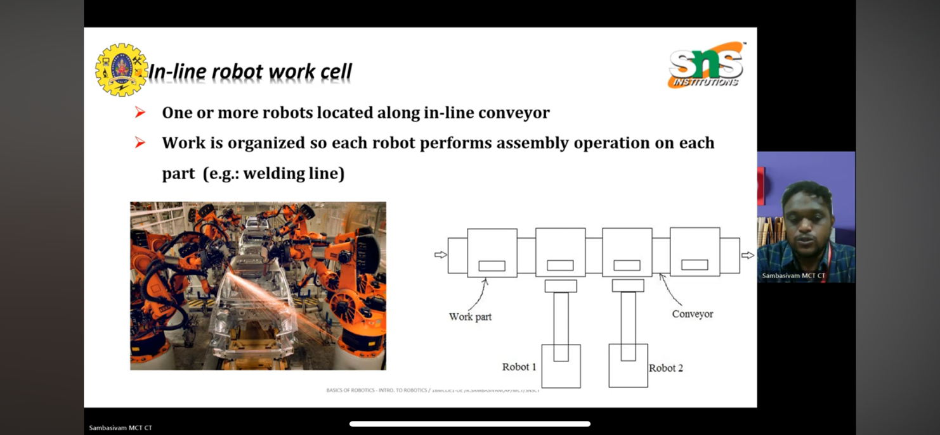Typical applications such as in welding lines焊接线 used to spot-weld car body frames, usually utilizes multiple robots.

There are 3 types of work part transport systems used in in-line robot work cell:

a) Intermittent Transfer  
b) Continuous Transfer  
c) Non-synchronous Transfer

**a) Intermittent Transfer System**

* The parts are moved in a start-and-stop motion from one station to another along the line. It is also called synchronous transfer since all parts are moved simultaneously to the next stop.
* The advantage of this system is that the parts are registered in a fixed location and orientation with respect to the robot during the robot’s work cycle.

**b) Continuous Transfer System**

* Work parts are moved continuously along the line at constant speed. The robot(s) has to perform the tasks as the parts move along机器人必须在零件移动时执行任务.
* The position and orientation of the parts with respect to any fixed location along the line are continuously changing.
* This results in a “tracking” problem, that is, the robot must maintain the relative position and orientation of its tool with respect to the work part.
* This tracking problem can be partly solved by the moving baseline tracking system i.e. by moving the robot parallel to the conveyor at the same speed, or by the stationary baseline tracking system i.e. by computing and adjusting the robot tool to maintain the position and orientation with respect to the moving part.

**c) Non-synchronous Transfer System**

* This is a “power and free system”. Each work part moves independently of other parts, in a stop-and-go manner.
* When a workstation has finished working on a work part, that part then proceeds to the next work station. Hence, some parts are being processed on the line at the same time that others are being transported or located between stations. Here, the timing varies according to the cycle time requirements of each station.
* The design and operation of this type of transfer system is more complicated than the other two because each part must be provided with its own independently operated moving cart.
* However, the problem of designing and controlling the robot system used in the power-and-free method is less complicated than for the continuous transfer method.
* For the irregular timing of arrivals, sensors must be provided to indicate to the robot when to begin its work cycle. The more complex problem of part registration with respect to the robot that must be solved in the continuously moving conveyor systems are not encountered on either the intermittent transfer or the non-synchronous transfer.
* Non-synchronous transfer systems offer a greater flexibility than the other two systems.
* Robot need to follow the speed of machine, so it need to adjust the speed (able to handle the work path, some work faster, some work slower or etc)

1. **Mobile Robot Work Cell**

* In this arrangement, the robot is provided with a means of transport机器人配备了运输工具, such as a mobile base, within the work cell to perform various tasks at different locations.
* The transport mechanism can be floor mounted tracks or overhead railing system that allows the robot to be moved along linear paths.

* Mobile robot work cells are suitable for installations where the robot must service more than one station (production machine) that has long processing cycles, and the stations cannot be arranged around the robot like a robot-centred cell arrangement.
* One such reason could be due to the stations being geographically separated by distances greater than the robot’s maximum reach. This type of layout allows for time-sharing tasks that will lower the robot idle time.
* One of the problems in designing this work cell is to find the optimum number of stations or machines for the robot to service.
* **Advantages of robot work cell**  
  - Less floor space required if using overhead railing system.  
  - **Increase the use of equipment and machinery**. Mobile robots help keep machines working non-stop, using them more efficiently and reducing idle time.   
  - **Reduced work-in-process inventory**. Robots move materials quickly between workstations, so there's less unfinished inventory stacking up.  
  - **Reduced raw material and finished goods inventory.** Robots deliver materials and move finished products just when needed, keeping stock levels lower and more manageable.  
  - **Reduces downtime by increasing productivity with constant workflow**. Robots work all the time without breaks, keeping things moving smoothly and reducing delays in production.

**Safety Monitoring (Definition)**

* Emergency stopping requires an alert operator to be present to notice the emergency and take action to interrupt the cycle (however, safety emergencies do not always occur at convenient times when the operator is present安全紧急情况并不总是发生在操作员在场的方便时间).
* Therefore, a more automatic and reliable means of protecting the cell equipment and people who might wander into the work zone is imperative至关重要的. This is safety monitoring.
* Safety monitoring (or hazard monitoring) is a work cell control function where various types of sensors are used for such purpose. For example, limit switches and proximity sensors can be used to monitor status and activities of the cell, to detect the unsafe or potentially unsafe conditions.
* Other type of sensors such as temperature sensors, pressure sensitive floor mats, light beams combined with photosensitive sensors, and machine vision can also be used to protect the cell equipment and people who might wander into the work zone.

**-----------------------------------------Study here get 25 marks----------------------------------**

**PID Controller**A **PID controller** is an instrument used in industrial control applications to regulate temperature, flow, pressure, speed and other process variables. PID (proportional, integral, derivative) controllers use a control loop feedback mechanism to control process variables and are the most accurate and stable controller.

* Proportional component: it can be considered as a virtual spring. A large proportional gain usually results in reduced rise time and steady-state error but it would also make the system overshoot and oscillate.
* Integral component: it ensures zero steady state error. A large integral gain will also make the system react faster to some constant error or disturbance, but can result in overshoot and makes transient response very poor.
* Derivative component: it should behave like a virtual damper. Increasing the derivative gain generally will reduce overshoot/oscillation. However, the derivative gain has no effect to the steady- state error and rise time.

General tips for designing a PID controller When you are designing a PID controller for a given system, follow the steps shown below to obtain a desired response.  
1. Obtain an open-loop response and determine what needs to be improved  
2. Add a proportional control to improve the rise time

3. Add a derivative control to improve the overshoot  
4. Add an integral control to eliminate the steady-state  
5. Adjust each of Kp, Ki, and Kd until you obtain a desired overall response.

For example, if a robot takes a reasonable amount of time to settle. Then it begins to oscillate again with bigger and bigger oscillations. This is probably due to Ki is too high and is causing ramp up. To fix this, reduce Ki.

You can always refer to the table to find out which controller controls what characteristics. Lastly, please keep in mind that you do not need to implement all three controllers (proportional, derivative, and integral) into a single system, if not necessary. For example, if a PI controller gives a good enough response, then you don't need to implement derivative controller to the system. Keep the controller as simple as possible.

Proportional-Derivative (PD) Control can be used to make the robot follows the line smoothly and make less error.

**Robotic Sensors (got time only read)**

**Passive被动sensors**: Passive sensors measure ambient周围的environment energy entering the system. Examples of passive sensor: thermocouple, camera, Light Dependent Resistor (LDR).

* Advantage – their operation conditions are not limited by the battery and that they are inexpensive / Simplicity of the design, therefore, low cost and low power consumption
* Disadvantage – can only be used to detect energy when the naturally occurring energy is available.

**Active sensors**: Active sensors emit发射 energy into the environment, and then measure the environment response. Examples of active sensor: laser range finders, sonar sensor.

* Advantage – is their ability to obtain measurements at any time, regardless of the time of day, season, or amount of natural illumination自然照明.
* Disadvantage – require the generation of a fairly large amount of energy to adequately illuminate the targets充分照亮目标.

**Proprioceptive sensors本体感受传感器** measure values internally to the system (robot), e.g. battery level, wheel position, joint angle, etc. Examples of proprioceptive sensors: encoders, potentiometers, compasses. **Exteroceptive sensors** are used for the observation of the environments and objects. Examples of exteroceptive: sonar sensors, ultrasonic distance sensors.

**Ultrasonic sensor** can be used for determining the proximity of objects (solid walls) while the robot is navigating. The ultrasonic sensor uses time of flight (TOF) method for distance measurement. In this method, the time taken for a pulse to travel from the transmitter to an observed object and back to the receiver is recorded and used to calculate distance by d=0.5*c*t , where d= distance between a sensor and an object, c=speed of light and t= time difference between the emission of a signal and its return to the sensor, after being reflected by an object

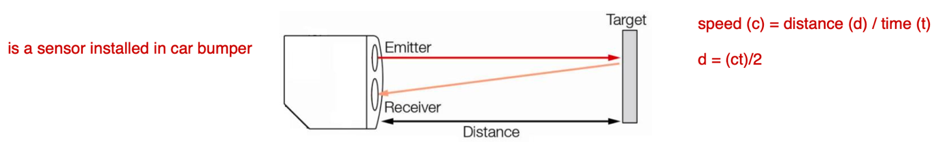

The ultrasonic sensor is attached in front of the robot. Whenever the robot is going on the desired path the ultrasonic sensor transmits the ultrasonic waves continuously from its sensor head. Whenever an obstacle comes ahead of it, the ultrasonic waves are reflected back from an object and that information is passed to the microcontroller of the robot. The microcontroller receives the data and performs the necessary movement of the robot to help the robot to avoid obstacle.

**Photoresistor**

A photoresistor is a light-dependent resistor (LDR) that covers the spectral光谱 sensitivity similar to that of the human eye. The active elements of these photoresistors are made of Cadmium Sulfide (CdS). Light enters into the semiconductor layer applied to a ceramic substrate and produces free charge carriers. A defined electrical resistance is produced that is inversely proportional to the illumination intensity. In other words, darkness causes more resistance, and brightness causes less resistance.

if room is bright, r will be low, v low

if room is dark, r will be high, v high

The resistance of a photoresistor decreases with light intensity. When the photoresistor is shaded, its resistance value is large, which in turn makes Vo smaller. If the I/O pin senses that voltage applied to it is above 1.6 V, it stores a 1 in its input register. On the other hand, when the photoresistor is not shaded, its resistance value is low. If it senses the applied voltage is less than 1.6 V, it stores a 0 in its input register. By comparing the value in the input register, the mobile robot can be programmed to recognize the difference between shade and no shade.

**Servo Motor**

* A servo motor is made up of a small DC motor, a gear transmission which reduces speed and increases strength, and a small circuit control that makes it possible to move the motor accurately.
* A typical Servo motor has three wires known as power, ground, and control. Servo motor usually does not rotate freely. Its rotation span is approximate 200 to 250 degree, except for the Parallax continuous rotation servo which can rotate freely. Servo motor requires a driver circuit.
* DC motor and shaft encoder could be an equivalent to servo motor, but without the gear arrangement part. Hence, it will have less torque than the servo motor. Servo motor has all the parts inside a single package and hence easy to use and compact as compared to the DC motors with encoders. Due to the absence of gear, DC motor with encoders is easier to repair and with no wear and tear problem. However, the servo motor will bring more accurate control.

* **The limitations of DC motors with encoders:**
* Inaccurate wheel diameter measurement or misaligned wheels..., the error of estimated position is generated by friction of ground surface..., some encoders which are installed externally are susceptible to dirt, oil and dust contaminates,...will lead to error accumulation over time
* Full speed clockwise requires 1.3 ms high pulses. To do this, use servo_speed(-75)

Explain the following snippet code:

from cyberbot import *

bot(18).servo_speed(75)

bot(19).servo_speed(-75)

sleep(3000)

bot(18).servo_speed(-75)

bot(19).servo_speed(-75)

**Architectures for Robot Control (Important in Exam)**

Mobile robot architecture can be classified according to the relationship between sensing, planning and acting components inside the architecture. Based on this, there are three types of architectures: reactive, deliberative, and hybrid (deliberative/reactive).

**Reactive Control**

* Reactive control or reactive planning involves using sensor data to react to obstacles in real time, making immediate adjustments to the robot's speed or trajectory to avoid collisions.
* Limitations to this approach are they only look up actions for any sensory input, do not usually keep much information around, have no memory, no internal representations of the world around them, and no ability to learn over time.
* Diagram of a light detector

  Description automatically generatedExample of reactive control is a light-chasing robot:

(behavior chase-light  
:period (1 ms)  
:actions ((set left-motor (right-sensor-value))

if right photo resister sensor detect light, then robot will move to right side, etc. (it use rule based system)

(set right-motor (left-sensor-value))))

**Deliberative Control**

* Deliberative planning, on the other hand, involves using a pre-built map of the environment to plan a collision-free path to the robot's destination.
* This can take a long time. However, if there is time, this allows the robot to act strategically.
* The deliberative systems were also used in non-physical domains, such as playing chess.

**Hybrid Control**

* In hybrid control, the goal is to combine the speed of reactive control and the brains of deliberative control. In it, one part of the robot's "brain" plans, while another deals with immediate reaction, such as avoiding obstacles and staying on the road.
* By combining these two approaches, robots can balance the need for fast, reactive obstacle avoidance with the ability to plan ahead for more complex environments.

* The three-layer hybrid architecture is often known as hybrid architecture which uses higher level planning in order to guide the lower level of reactive components.
* The bottom layer is the reactive/behavior-based layer, in which sensors and actuators are closely coupled
* The upper layer provides the deliberative component such as planning and localisation.
* The control execution layer is responsible to supervise the interaction between the high level layer and low level layer / The control execution layer combines the speed of reactive control and the brains of deliberative control.

When we compare deliberative architectures with reactive architectures, we observe that deliberative architectures work in a more predictable way, have a high dependency of a precise and complete model of the world, and they can generate optimized trajectories for the robot. On the other end, reactive architectures have a faster response to dynamic changes in the environment, can work without a model of the world, and are computationally much simpler. Finally, hybrid architectures try to present the best characteristics of the other two architectures.

Challenges involved in developing effective obstacle avoidance algorithms for robots.

* Obstacles can appear suddenly, and their size, shape, and location can vary widely.
* Robots must be able to make decisions in real time, considering their current speed and trajectory弹道, as well as the proximity and movement of nearby obstacles.

**Final (1 sentence two marks)**

**Work cell, Reactive and deliberative (6m)**

--> The reactive approach allows robots to respond quickly without relying on complex or extensive computation. It is used in real-time applications and utilizes sensors, such as those for avoiding obstacles, to enable immediate reactions.

--> The deliberative approach, on the other hand, involves planning and reasoning, relying on maps for complex tasks that require long-term planning. Exp, playing chess.

--> Hybrid robots integrate both approaches, balancing speed and intelligence, adapting to dynamic environments, and providing strategic decision-making.

**ROS CODE (15 marks)**

#!/usr/bin/env python

import rospy

import time

from geometry_msgs.msg import Twist

pub = rospy.Publisher('turtle1/cmd_vel', Twist, queue_size=10)

rospy.init_node('mynode', anonymous=True)

command = Twist()

time.sleep(0.5)

command.linear.x = 2.0

command.angular.z = 1.0

rospy.loginfo(command)

pub.publish(command)

**Revision1**

25 marks – work cell

15 marks – code

6 marks – control

---------------------------

46 marks

**4/4/2025 – this get 75 marks**

**Work Envelope工作范围**

* The **work envelope** refers to the **working volume** which can be reached by some point at the end.
* It is important for manufacturers to work with robotic companies to determine how much robotic workspace is needed when designing the system. If a facility is too small, it may not be suited for a large robot, or the robot’s operation may be destructive.
* One thing that is necessary is that human workers stay out of a robot’s workspace during operation. While humans may be able to enter each other’s workspace, entering a robot’s workspace could result in injury or death, due to the amount of speed and force with which a robot works.

**Cartesian Robot**

* Cartesian robot has a cubic or rectangular work envelope
* Characteristics: Cartesian robot has three linear movements. There are no dead zones within the working envelope and the robot can manipulate its maximum payload throughout the working volume在整个工作范围内操纵其最大有效载荷.
* Advantages: Cartesian robot has rigid structure and thus usually can offer good levels of precision and repeatability
* Applications: Cartesian robot is used for pick and place work, assembly operations, handling machine tools and arc welding

Draw box enough

**Cylindrical Robot**

* Cylindrical robot has a cylindrical work envelope.
* Characteristics: Two linear movements, one rotational. The cylinder is hollow空洞的, since there is a limit to how far the arm can retract, this creates a cylindrical dead zone around the robot structure因为手臂缩回的距离是有限的，这在机器人结构周围形成了一个圆柱形的死区
* Advantages: Cylindrical robot is good for reaching deep into machines, save on floor space, and tend to have the rigid structure needed for large payloads往往具有大有效载荷所需的刚性结构.
* Applications: Cylinder robots are used in assembly operations, handling of machine tools, spot welding, and handling at die cast machines压铸机.

draw a cylinder

**Spherical Robot/ Polar Robot**

* Spherical robots have a spherical work envelope
* Characteristics: A spherical robot has 1 linear axis, 2 rotating axes/ Long horizontal reach but with short vertical reach
* Advantages: Rigid structure and easily visualize/ Large workspace for size/ Easily computed kinematics.
* Applications: Palletizing, loading and unloading/ Material transfer, foundry and forging

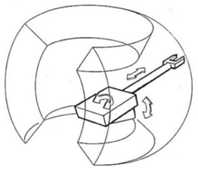

**Selective Compliance Assembly Robot Arm (SCARA)**

* SCARA robot has kidney shaped prism肾形棱柱体 of work envelope, having a circular hole passing through the middle.
* Characteristics: A SCARA robot has 1 linear axis, 2 rotating axes (same as spherical)
* Advantages: Excellent repeatability and fast cycle times/ Large workspace/ Height axis is rigid
* A drawing of a metal object

  Description automatically generatedApplications: Pick-and-place or assembly operations where high speed and high accuracy is required.

For a robot manipulator to be able to arbitrarily position and orientate an object in 3D space, the manipulator should have 6 degrees of freedom, i.e., 3 for positioning a point on the object and 3 for orienting the object with respect to a reference coordinate frame. Specifically, the body is free to change position as forward/backward (surge), up/down (heave), left/right (sway) translation in three perpendicular axes, combined with changes in orientation through rotation about three perpendicular axes, often termed yaw (normal axis), pitch (transverse axis), and roll (longitudinal axis).

**Articulated Robot**

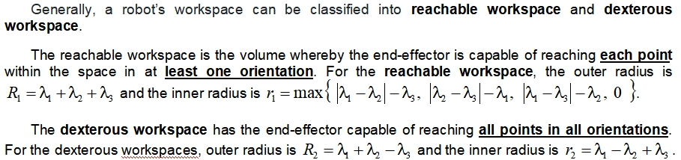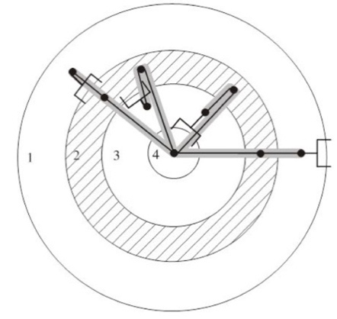 Exam need to draw and memories formula

**Forward Kinematics (FK)**:  
Given the joint angles of a robotic arm, forward kinematics calculates the position and orientation of the end effector. It follows a straightforward computation using transformation matrices.

Forward Kinematics is important for planning the motion of robotic manipulators. It enables the determination of where the end-effector will be located in the workspace for a given set of join angles.

**Inverse Kinematics (IK)**:  
Given the desired position and orientation of the end effector, inverse kinematics determines the required joint angles. This is more complex as multiple or no solutions may exist, often requiring numerical methods or optimization techniques.

**Path Integration**

* Path integration uses basic geometry to work out the position of a robot, given an initial position and knowledge of the movement that occurred.
* A simple case is where the robot makes independent rotations and straight line movements. It could use an optical encoder on its wheels to estimate the heading angle θ and the distance travelled, d. Then xt = xt−1 + dcosθ and yt = yt−1 + dsinθ. Problems with path integration occur because small errors in the distance or heading estimate can accumulate into large errors in position.
* A popular solution is to have some external reference points in the world that can be used to recalibrate重新校准 the system. These points are called landmarks. They are perceptual distinctive features in the environment that the robot can recognise, preferably from difference viewpoints, and use to orient itself.
* A road sign is an example of an artificial landmark (i.e. one introduced for the purpose of navigation) whereas a tree might serve as a natural landmark, i.e. something already existing in the environment that can be adopted for navigation. Good properties for a landmark is that it does not move or change, can be detected over a wide area, and is unique.

**Explain how robot can navigate safely while avoiding obstacles – ask you to design a robot to carry book, find book, return book, navigation in library –no need gps (6-8marks)**

Sensors like cameras, LiDAR, ultrasonic sensors, and GPS collect environmental data to detect obstacles, determine position, and generate a real-time map using Simultaneous Localization and Mapping (SLAM). The onboard processor analyzes this data to make navigation decisions and sends commands to actuators, such as motors, that control the wheels and robotic arms. Effectors, including wheels and grippers, carry out the physical actions needed for movement and book delivery. By functioning together, these components allow the robot to navigate efficiently, avoid obstacles, and complete deliveries successfully.

**Actuators – given scenario, need to see which to apply in, to compare**

Electric actuators convert electrical energy into mechanical motion using motors such as servo, stepper, or linear actuators. They provide high precision, fast response, and energy efficiency, making them well- suited for automation and precise movement. Compared to hydraulic actuators, which generate high force using pressurized fluid, electric actuators are cleaner, require less maintenance, and are more efficient but may not deliver the same force output. Pneumatic actuators, powered by compressed air, enable rapid motion but are less precise and energy-efficient due to air compressibility. While hydraulic and pneumatic actuators are ideal for high-force applications, electric actuators excel in robotics where accuracy and efficiency are crucial. **As a conclusion, xx is most suitable in this scenario.**

**Sensor fusion -- develop a robot, then is lack of some part, write what part and why use this part**

**One sensor is not sufficient to solve the problem, what is ur proposed solution: so we need to integrate multiple sensor together, this is called sensor fusion.**

Sensor fusion enhances robot behaviour and decision-making by integrating data from multiple sensors, improving perception and accuracy. Individual sensors have limitations, such as noise, blind spots, or environmental interference, but combining data from different sources provides a more reliable and comprehensive understanding of the surroundings. In autonomous robots, for example, merging data from LiDAR, cameras, ultrasonic sensors, and GPS enables precise navigation and object detection, even in challenging environments. Sensor fusion helps robots distinguish obstacles from safe pathways, enhances localization accuracy, and supports better decision-making by leveraging multiple data points. Additionally, it improves redundancy and fault tolerance, allowing robots to continue operating even if one sensor fails. By processing and analyzing data collectively, sensor fusion increases efficiency, adaptability, and intelligence, making robots more effective in applications such as self-driving cars, industrial automation, and medical robotics.

**11/4/2025 (Important for all)**

**Motion planning algorithm (process)**

* **Sensing**: The robot gathers information about its environment using sensors, such as LiDAR, cameras, or proximity sensors.
* **Mapping**: Based on the sensor data, the robot creates a map of the environment, identifying obstacles, boundaries, and other relevant features.
* **Path** **generation**: The algorithm generates a path from the current position of the robot to the desired goal location. This may involve searching for a feasible path through the map while avoiding obstacles and considering constraints such as robot dynamics and workspace limitations.
* **Trajectory planning:** Once a path is determined, the trajectory planning phase refines the path by considering factors such as robot dynamics, velocity profiles, and collision avoidance. This ensures smooth and efficient movement along the planned path.
* **Execution**: The robot executes the planned trajectory, continuously monitoring its surroundings and making necessary adjustments to adapt to changing conditions

**Reactive sensing反应传感**: Various sensory systems can be utilised. The simplest is a whisker sensor that triggers a switch upon encountering an obstacle. For avoiding any contact, a proximity sensor like reflected IR could be used. Range sensors such as sonar or laser sensors enable detection of obstacles over longer distances by sending out a signal and measuring the time for the reflection to return. However, they may encounter errors if the reflection is not clear.

**Pre-planned routes (SLAM):** Robot to have a clearer understanding of its surroundings and current position. This typically involves creating a map of open space and finding a connected path through it to reach the goal. One example is using simultaneous localisation and mapping (SLAM).

**Proportional-integral-derivative (PID) control**: PID control is a classic feedback control technique that adjusts the output of a system based on the proportional, integral, and derivative terms of the error signal. It is effective for linear systems and offers simplicity and ease of implementation but may struggle with nonlinear or complex systems. PID control is more suitable for well-defined systems with known dynamics.

**Fuzzy logic control**: Fuzzy logic control uses linguistic语言 variables and fuzzy rules to capture human-like decision-making processes. It can handle nonlinearities and uncertainties more effectively but may require more computational resources and tuning effort调整工作. Fuzzy logic control is more adaptable to uncertain and complex environments.

**Inertial惯性 navigation systems (INS):** INS relies on accelerometers and gyroscopes to track position, velocity, and orientation without requiring external signals. This makes it highly effective in environments where GPS signals are weak or unavailable, such as underground, underwater, or indoors. However, INS suffers from drift over time, requiring periodic correction. INS is preferable in environments where continuous tracking without external signals is needed.

**GPS-based navigation:** GPS-based navigation provides accurate global positioning by receiving satellite signals, making it ideal for outdoor applications like autonomous vehicles and drones. GPS is limited by signal loss in tunnels隧道, dense urban areas人口密集的城市地区, or heavily forested regions森林茂密的地区. GPS is more suitable for large-scale outdoor navigation.

**Robot Operating System**

* The Robot Operating System (ROS) is a flexible framework for writing robot software. It is a collection of tools, libraries, and conventions 习俗that aim to simplify the task of creating complex and robust robot behavior across a wide variety of robotic platforms.
* ROS provides a broad collection of integrations open-source libraries that implement useful robot functionality, with a focus on mobility, manipulation, and perception.
* ROS also provides an extensive set of tools for configuring, starting, debugging, simulating, testing, and stopping robot systems.
* The **ROS Master** provides name registration and lookup to the rest of the nodes. Nodes would not be able to find each other, exchange messages, or invoke services without the ROS Master. Nodes are processes that perform computation.
* A **ROS node** is written with the use of a ROS client library, such as roscpp or rospy.

**Publish-subscribe model of ROS**

ROS topic operates on a data push mechanism. A node that produces data (a publisher) publishes messages to a specific topic, and any interested nodes (subscribers) receive those messages.

* The publisher pushes data to the topic, and subscribers pull the data when they are ready to process it.
* This decoupled communication paradigm范例 enhances modularity and flexibility in robotic systems, allowing nodes to communicate asynchronously without requiring direct connections or knowledge of each other's existence.
* The data push mechanism enables real-time and efficient information exchange in ROS, supporting the development of modular and distributed robotic applications.

**Modular design of Robot Operating System (ROS)**

The Robot Operating System (ROS) follows a distributed architecture based on nodes, topics, services, and actions, enabling modular and scalable robot development.

* Nodes are individual processes that perform specific tasks, such as sensor data processing or motor control.
* Topics facilitate communication between nodes using a publish-subscribe messaging system, where nodes can publish messages to a topic while others subscribe to receive them.
* Services enable synchronous communication between nodes through a request-response mechanism, allowing direct interactions when needed.
* Parameter server stores configuration parameters accessible to all nodes, enhancing reusability and system tuning.
* The ROS Master plays a crucial role in managing node registration and communication, ensuring connectivity across the system.
* By following this modular design, ROS promotes reusability, flexibility, and interoperability互操作性, making it a standard framework for modern robotics research and development.

**Gazebo in ROS**

* Gazebo provides realistic physics-based simulation, incorporating factors such as gravity, friction, and collisions to ensure accurate robot behavior.
* Gazebo supports sensor emulation, enabling the simulation of cameras, LiDAR, IMUs, and other sensors essential for perception algorithm development.
* Gazebo allows users to customise simulation environments to match real-world applications, making it a valuable tool for prototyping. By facilitating rapid prototyping, it helps reduce costs and risks by allowing developers to test algorithms without the need for physical robots.
* Gazebo supports multi-robot testing, making it ideal for evaluating coordination strategies and swarm蜂群 robotics applications. This allows researchers and developers to simulate complex interactions between multiple robots before deployment.
* By using Gazebo, developers can iteratively refine robotic systems, optimise parameters, and troubleshoot issues in a safe and controlled environment before real-world deployment.

**ROS package**

* A ROS package is a collection of ROS nodes, configuration files, and other resources that together provide a specific functionality.
* A ROS package is structured as a directory that contains a manifest file, which describes the package dependencies and other metadata, as well as directories for nodes, configuration files, and other resources.

**Application of Computer Vision in Robotic**

The first process to extract the information from the camera is data pre-processing. To pre- process the data, the continuous video is first sampled into images. The RGB image is then transformed to HSV or YUV which is a more perceptually uniform colour space. Color normalization is used to handle non-uniform lighting across the field. Adaptive colour histogram is used to remove the background, in this case the green field colour.

After the data is pre-processed, image segmentation is perform to extract useful information. To segment the image, each image pixel is classified into different classes of object (robots and ball) using thresholding method. The threshold image is dilated to fill holes which might appear inside a region. The relevant information such as the colour, area, and bounding box are computed from the segmented region. This information is stored in a data structure for recognition to be done.

After image segmentation, the objects in the image must be classified. In the classification process, the set of attributes assigned in the rules to the objects of interest is recognized. For example, the ball is an orange spherical object and smaller in size, thus it can be detected as a small orange circular region on the image plane. Robots are detected as red or blue regions (the team colors). The goals are detected as large yellow objects on the image. Thus, the objects can be classified.

One of the possible challenges of implementing computer vision is the narrow field of view achieved if a single camera is used. Although special lenses can be mounted to the camera to broaden the field of view, they cause image deformation. Using two cameras can improve the field of view. However, this method causes higher image processing complexity as well as doubling required hardware. Another challenge is real-time reaction has to be achieved. Higher image resolutions result in better precision to image segmentation but also increase the time to process each image since the bigger the image the longer it takes to be analysed.

**Revision 1 – 46marks**

**Revision 2 – 75marks**

**Revision 3 – 40+marks**

**----------------------------**

**Total 160marks**